**Running the BNY Data POC :**

**Objective :**

To load data from 3 sources (MySQL, Mongo and CSV), join it and run a few queries and show visualization in a Zeppelin notebook.

**Setup and Softwares used :**

1. Gigaspaces-insightedge-enterprise-15.2.0-m10
2. Mongodb (For installation follow the steps provided in link <https://docs.mongodb.com/manual/tutorial/install-mongodb-on-ubuntu/>)
   1. Create user using <https://docs.mongodb.com/manual/reference/method/db.createUser/>
   2. User and Password used for POC

user : mongodb, password: mongodb

1. Mysql (For installation follow the steps provided in link <https://www.digitalocean.com/community/tutorials/how-to-install-mysql-on-ubuntu-18-04>)
   1. User and Password used for POC

user : root, password: mysql

1. Create database: opsdb
2. Go to insightedge lib folder and perform steps below :
   1. Copy the xap-mongodb.jar and antlr4-runtime-4.0.jar from lib\optional\mongodb to lib\optional\pu-common.
   2. Download mongo-java-driver-3.2.0.jar from <http://docs.mongodb.org/ecosystem/drivers/java/> and copy it to lib\optional\pu-common.

**Running the POC :**

1. Clone this project.
2. Run ‘mvn clean install’ inside mongo-stateful-with-db.
3. Start insightedge.
4. Deploy PU from web-ui and select jar file from mongo-stateful-with-db/my-app-space/target/my-app-space-0.1.jar
5. Run main method of Program class from mongo-stateful-with-db/my-app-feeder/src/main/java/
6. Verify the web-ui -> spaces that it has all data loaded in space from Mysql, CSV (stockPrice.csv) and Mongodb. Attached is a screenshot of it.

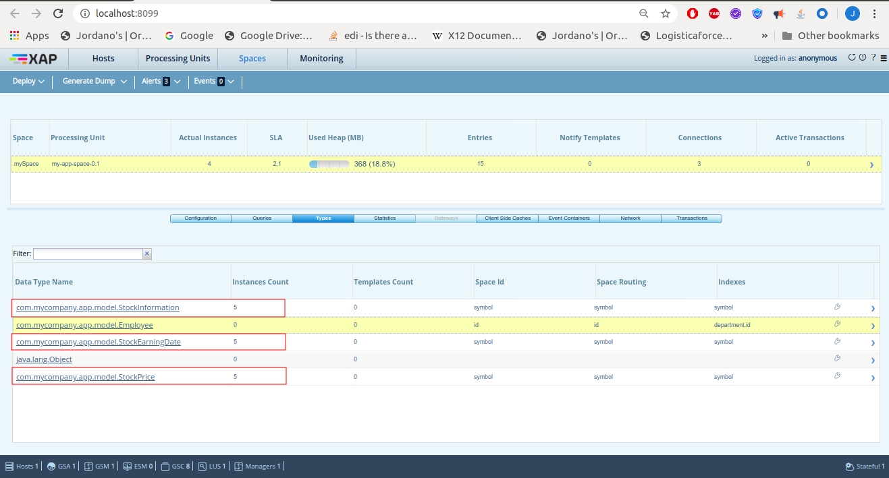

1. Go to Zeppelin at localhost:9090 and import the note ‘BYN POC.json’.
2. Now go to BYN POC notebook and run all the paragraphs.
3. Attached is a screenshot of the output.

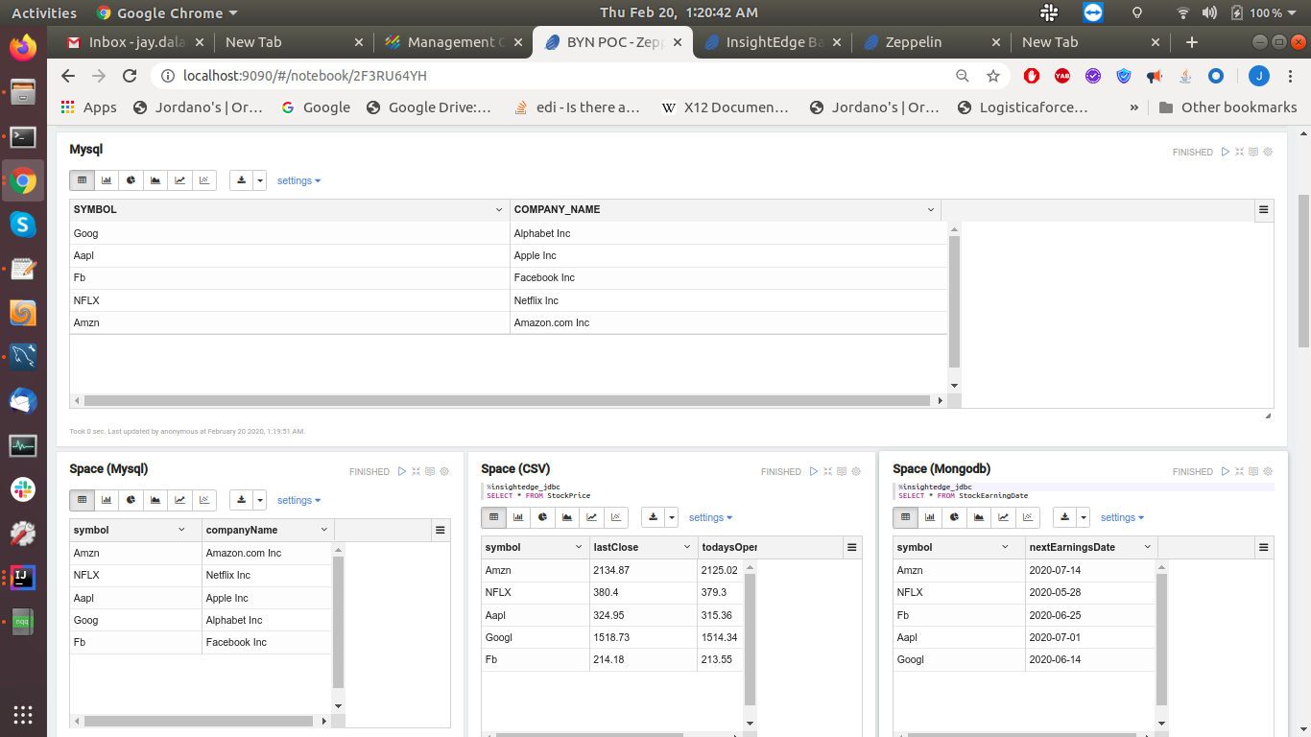

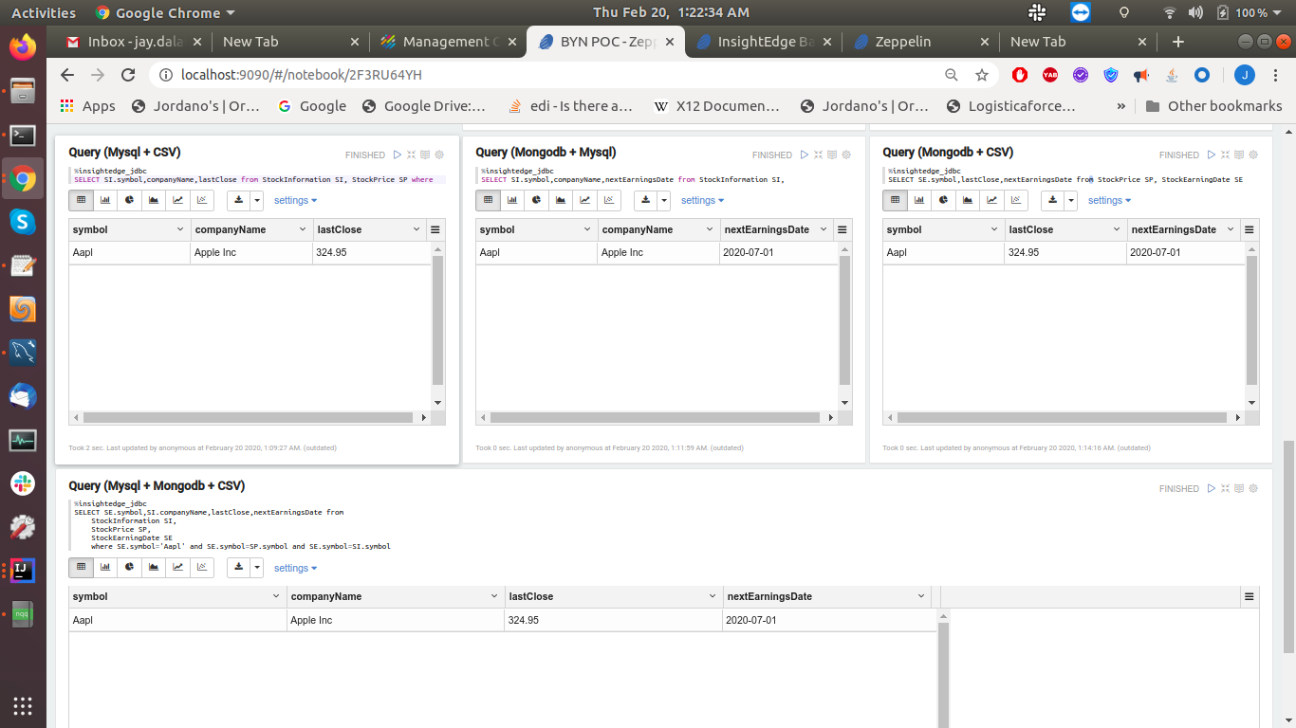

**Some Useful mongo cmd from shell :**

mongo (To start mongo shell)

use opsdb; (to create and use database named opsdb)

show collections; (to show list of tables)

db.Employee.insert({"id":"1000","name":"Franklin Kassulke DDS","title":"Lead Design Developer","department":"support","birthday":"1995-02-14","salary":"4951.05"}); (To create and insert data to Employee table)

db.Employee.find( {} ) (To select data from Employee table)